12.Perform a 270-degree rotation clockwise along the y-axis for the given image.

**AIM:**

To perform a 270-degree clockwise rotation along the Y-axis for a given image using Python.

**PROCEDURE:**

1. Install OpenCV if not already installed using:

2. Import the cv2 module.

3. Read the input image using cv2.imread().

4. Flip the image horizontally using cv2.flip(image, 1), which mirrors the image along the Y-axis.

5. Rotate the image by 270 degrees using cv2.rotate(image, cv2.ROTATE_90_COUNTERCLOCKWISE).

6. Display the original and transformed images using cv2.imshow().

7. Save the transformed image using cv2.imwrite(), if needed.

8. Wait for a key press and close all image windows using cv2.waitKey(0) and cv2.destroyAllWindows().

**PROGRAM:**

import cv2

image = cv2.imread("image.jpg")

flipped_image = cv2.flip(image, 1)

rotated_image = cv2.rotate(flipped_image, cv2.ROTATE_90_COUNTERCLOCKWISE)

cv2.imshow("Original Image", image)

cv2.imshow("Rotated 270-degree Clockwise Along Y-axis", rotated_image)

cv2.imwrite("rotated_image_270.jpg", rotated_image)

cv2.waitKey(0)

cv2.destroyAllWindows()

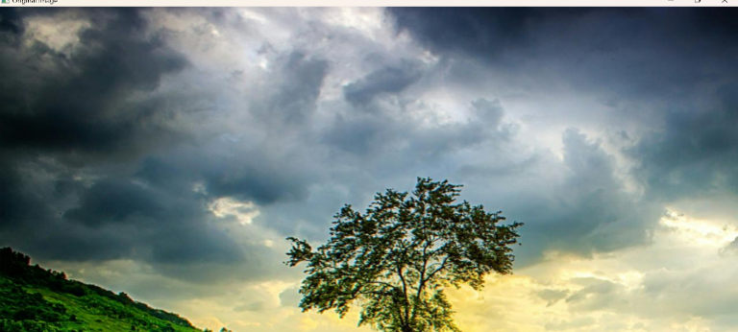

**INPUT:**

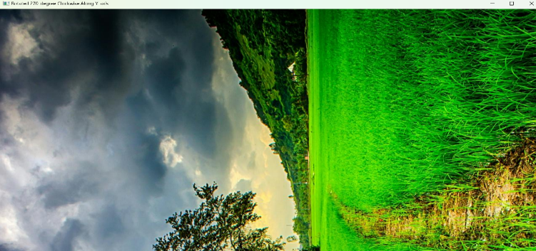

**OUTPUT:**

**RESULT :**

The program successfully performs a 270-degree clockwise rotation along the Y-axis on the given image, displays it, and saves it as "rotated_image_270.jpg".

n